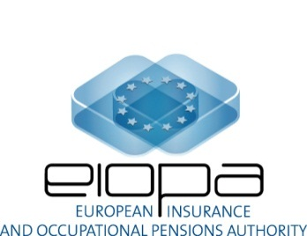

EIOPA-13/076
20 March 2013
Overall results of the comply or explain
On Guidelines

Title of Guidelines | Guidelines on Complaints Handling by Insurance Undertakings
Deadline for replies | 15th January 2013.
No. of NCAs and/or FIs that replied | 32 NCAs including:  27 EU Member States NCAs  Non-EU EEA NCAs (Iceland, Liechtenstein, Norway)  EU accessing countries: Croatia  UK overseas territories: Gibraltar.
Results | All NCAs confirmed their compliance or intention to comply with the Guidelines.  With few exceptions, they provided links to existing or planned national measures to incorporate the Guidelines.
Published in EIOPA’s website | https://eiopa.europa.eu/publications/eiopa-guidelines/index.html

